HEART RATE RESPONSE TO INDUCED ENVIRONMENTAL AND MODULATORS IN FRESHWATER SHRIMP: A STUDENT LABORATORY EXERCISE
Introduction
The purpose of this exercise is to investigate the effect of various environmental cues on the heart rate of the transparent ghost shrimp, Palaemonetes genus. Heart rate in crustaceans can be altered under many conditions. Neurotransmitters, temperature, and chemicals such as stimulants can all have an effect. Neurotransmitters act on the organism’s heart rate through the nervous system in a parasympathetic-like or sympathetic-like manner. This can either cause an increase or decrease in overall heart rate based on the properties of the neurotransmitter in question. The effects of temperature on heart rate are also variable. Lower temperatures tend to decrease the heart rate. Conversely, high temperatures tend to cause an increase in heart rate due to the increase in metabolic activity and higher rate of chemical reactions within the body. Chemical stimulants also increase the heart rate and blood flow. In this experiment, students will become familiar with these effects by subjecting a species of freshwater shrimp to varying environmental conditions- dopamine, serotonin, and cold water.

Preparation
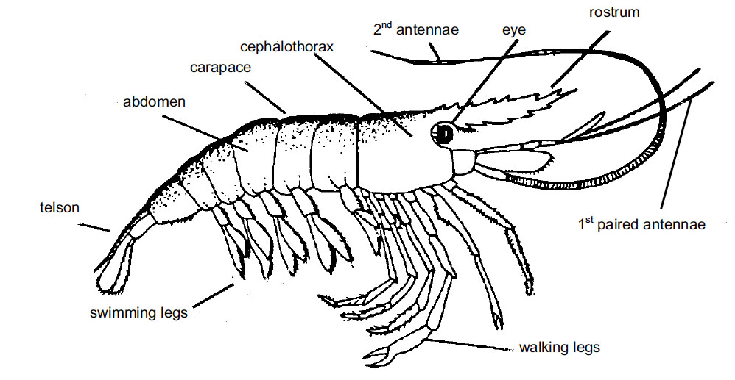
The ghost shrimp is an ideal experimental model for monitoring heart rate, due to the organism’s transparent exoskeleton and low maintenance. Before starting this experiment, become familiar with the shrimp anatomy terms below:

FIG 1. General shrimp anatomy diagram.
http://www.greymatter.net.au/sciweb/activity/AC/handouts/anatomysho1.pdf

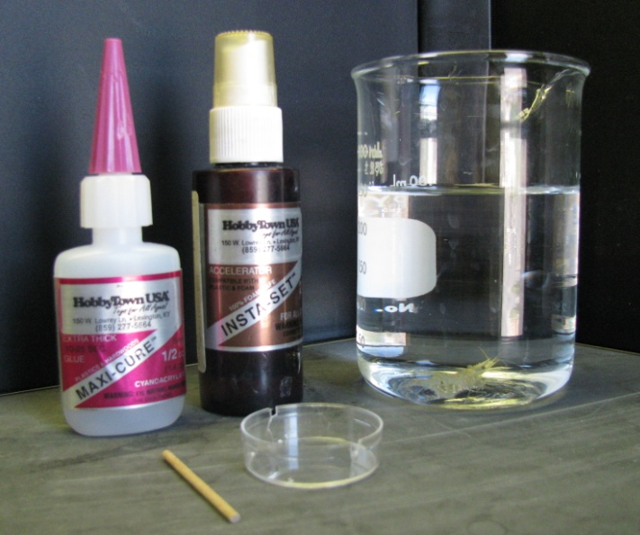
Materials
Item | Quantity
Ghost Shrimp (available at pet stores) | 1
Small Wooden Rod (Toothpick) | 1
Grooved Petri Dish | 1
Light Microscope | 1
Pins with Curled Ends | 2
Paper Towels | 2
Beaker of Distilled, Aerated Water | 2
Beaker of Ice | 1
10 μM 5-HT Solution | 1 Bath
10 μM Dopamine Solution | 1 Bath
Set of Microscope Lights | 1
Drop of Super Glue (Maxi-Cure) | 1
Drop of Quick Dry (Insta-Set) | 1

Methods
- Dampen a paper towel with distilled water.
- Place the shrimp in the damp paper towel so that the anterior region is wrapped and the animal’s back and tail are free.
- With a second, dry paper towel gently dab the back of the animal in order to dry it for the glue.
- Place a small drop of the glue onto the wooden rod and then adhere it to the animal. Ensure that the stick is glued slightly below the back on the tail so that the apparatus does not hide the heart.
- While holding the rod in place, place a dab of the quick dry compound over the glue to complete the bonding.
- Hold the stick in place for approximately five more seconds or until the rod is sufficiently affixed to the shrimp.
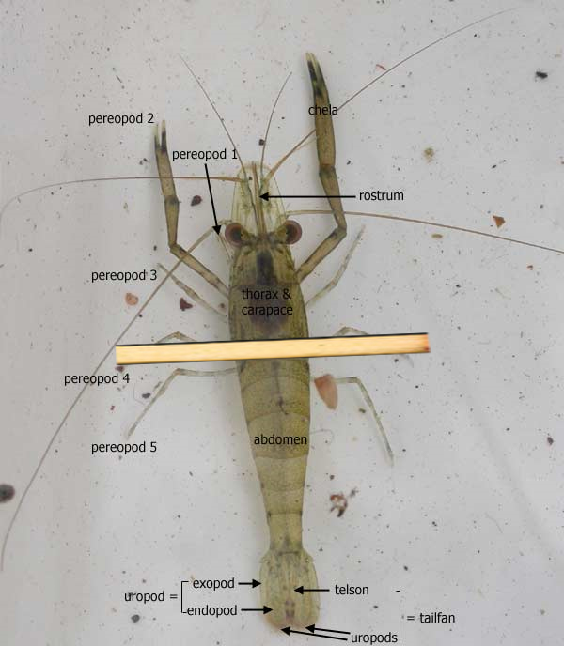

FIG 3. Diagram of wooden rod placement on dorsal side of shrimp. Source: <www.mdfrc.org.au/BugGuide/diagrams/decapoda.htm>
>

- Rinse the shrimp and rod of any excess chemicals by dipping it once or twice into the beaker of water.
- Place the shrimp in the grooved Petri dish; ensure that the rod fits securely into both grooves on either side of the dish. This will limit the animal’s movement and will allow for it to be monitored through the microscope. Fill the dish with aerated water and be sure that the level is over the back of the shrimp so that it survives the experiment.
Exercise 1.
Monitor the heart rate of the shrimp to gain a baseline. To do this, place the shrimp setup under the microscope so that the heart is visible on the back of the animal. Count the number of beats in ten seconds and multiply this number by six to get the beats per minute. To obtain an experimental baseline, do this three times and take the average of the three values and record values in Table 1. Note: It may be beneficial to allow the shrimp to acclimate for approximately five to ten minutes before taking a baseline reading to account for the agitation of the animal.
Exercise 2.
Note: Your teacher will instruct your group to perform either Part A or Part B of Exercise 2 (NOT both). You will then exchange recorded data with a group that used a different chemical stimulus.
A. Carefully transport the dish containing the shrimp to the sink and gently pour the contents of the bath out. Make sure that the shrimp is secure and does not fall into the sink. While monitoring the shrimp heart rate through the microscope, fill the bath with the prepared dopamine solution. Take note of the immediate response. After approximately thirty seconds, take note of the number of heart beats in a ten second period. Again, multiply this number by six in order to calculate beats per minute. As in Exercise 1, repeat this process for a total of three times; generate an average beats per minute reading and record it in Table 1.
B. Carefully transport the dish containing the shrimp to the sink and gently pour the contents of the bath out. Make sure that the shrimp is secure and does not fall into the sink. While monitoring the shrimp heart rate through the microscope, fill the bath with the prepared serotonin solution. Take note of the immediate response. After approximately thirty seconds, take note of the number of heart beats in a ten second period. Again, multiply this number by six in order to calculate beats per minute. As in Exercise 1, repeat this process for a total of three times; generate an average beats per minute reading and record it in Table 1.
Exercise 3.
Carefully transport the dish containing the shrimp to the collection beaker in the classroom. Gently pour out the solution containing either GABA or glutamate. Make sure that the shrimp is secure. Rinse the beaker and the shrimp with aerated water to ensure that all of the chemicals have been removed. While monitoring the shrimp heart rate through the microscope, fill the bath with chilled aerated water from the beaker containing the ice. Observe the immediate change. After approximately thirty seconds, take note of the number of heart beats in a ten second period. Again, multiply this number by six in order to calculate beats per minute. As in the previous exercises, repeat this process three times; generate an average beats per minute reading and record it in Table 1. Water Temperature: _______ °C

Exercise 4.
Gently pour out the cold water. Make sure that the shrimp is secure. While monitoring the shrimp heart rate through the microscope, fill the bath with warm aerated water from the beaker. Observe the immediate change. After approximately thirty seconds, take note of the number of heart beats in a ten second period. Again, multiply this number by six in order to calculate beats per minute. As in the previous exercises, repeat this process for a total of three times; generate an average beats per minute reading and record it in Table 1. Water Temperature: _________°C
Results:

Table 1
 | Control (beats/min) | Dopamine (beats/min) | Serotonin (beats/min) | Cold Water (beats/min) | Warm Water (beats/min)
Trial 1
Trail 2
Trail 3
Average

In order to compare the effects upon heart rate of the various conditions observed above, graph the average beats/minute of each stimulus below:
Heart Rate (Beats/Min)
Control Dopamine Serotonin Cold Warm
To account for the effects of non-target variable conditions such as experimenter noise or changes in the amount of light over the shrimp with passing shadows, it is important to calculate the percent difference from baseline for each of the stimuli observed before drawing any conclusions about generalized reaction trends.
$$\% Difference= \frac{Absolute differnce (intial-experimental)}{intial}x100$$

 | Dopamine | Serotonin | Cold Temperature | Warm Temperature
Percent Difference

References
Alexandrowicz, J. S. 1932. The innervation of the heart of Crustacea. I. Decapoda. Wuart. J. Microsc. Sci., 75: 181-249.
Bethe, A. 1897. Vergleichende Untersuchungen uber die Funtionen des Zentrainervensystems der Arthropoden. Pfluger’s Arch. Ges. Physiol., 68: 449-545.
Bierbower SM and Cooper RL. 2009. Measures of Heart and Ventilatory Rates in Freely Moving Crayfish. JoVE. 32. http://www.jove.com/index/details.stp?id=1594
Bierbower, S.M. and Cooper, R.L. (2010) The effects of acute carbon dioxide on behavior and physiology in Procambarus clarkii. Journal of Experimental Zoology Journal of Experimental Zoology 313A:484-497
Burmistrov, Y. M. and Z. P. Shuranova. 1996. Individual features in invertebrate behavior: Crustacea. In: Abramson Cl, Shuranova ZP, Burmistrov YM (eds) Russian Contributions to Invertebrate Behavior. Praeger, Westport, Connecticut. Pp. 111-144.
Carpenter, M. B., 1976. The autonomic nervous system. Human Neuroanatomy, 7th ed. The William & Wilkins Co, Baltimore, MD, pp. 191-212.
Cooper, A.S., Rymond, K.E., Ward, M.A., Bocook, E.L. and Cooper, R.L. (2009) Monitoring heart function in larval Drosophila melanogaster for physiological studies. Journal of Visualized Experiments (JoVE) 32: http://www.jove.com/index/details.stp?id=1596
Cuadras, J., 1979. Heart rate and agonistic behavior in unrestrained crabs. Mar. Behav. Physiol., 6: 189-196.
Cuadras, J., 1980. Cardiac responses to visual detection of movement, mechanostimulation and cheliped improsed movement in hermit crabs. Comp. Biochem. Physiol. A, 66: 113-1171.
Huxley, T.H., 1880. The Crayfish: An introduction to the study of zoology, New York: D. Appleton and Company, 1880, v. XXVIII of the international Scientific Series. Reprinted 1973, 1974, 1977, MIT Press, Cambridge, MA.
Li, H., L.R. Listerman, D. Doshi, and R. L. Cooper, 2000. Use of heart rate to measure intrinsic state of blind cave crayfish during social interactions. Comp. Bichem. Physiol., 127A: 55-70.
Listerman, L.R., J. Deskins, H. Bradacs, and R.L. Cooper, 2000. Heart rate within male crayfish: Social interactions and effects of 5-HT. Comp. Biochem. Physiol., 125A: 251-263.
McMahon, B.R., and J.L. Wilkens, 1983. Ventilation, perfusion and oxygen uptake. In: Mantel, L., Bliss, D. (eds), Biology of Crustacea, 6. Academic Press, New York, pp. 289-372.
Mendelson, M., 1971. Oscillator neurons in crustacean ganglia. Science, 171: 1170-1173.
Nicholls, J.G., A.R., Martin, B.G. Wallace, and P.A. Fuchs, 200. From Neuron to Brain. Sinauer Assoc., Sunderland, MA, USA. pp. 315-317.
Orlov, Y., 1927. Das Magenganglion des Fluβkrebses, Ein Beitrag zur vergleichenden Histologis des sympathischen Nervensystem. Z. Mikrosk. Anat. Forschung 8 (1), 67-102.
Pasztor, V.M., 1968. The neurophysiology of respiration in decapod Crustacea: The motor system. Can. J. Zool., 46: 585-596.
Schapker, H., T. Breithaupt, Z. Shuranova, Y. Burmistrov, and R.L. Cooper, 2002. Heart rate and ventilatory correlative measures in crayfish during environmental disturbances and social interactions. Comp. Biochem. Physiol., A 131: 397-407.
Shuranova, Z.P., A.V. Vekhov, and Y.M. Burmistrov, 1993. The behavioral reactions of fresh-water crayfish to sensory exposures: the autonomic components. Zh. Vyssh Nerv. Deiat Im I P Pavlova, 43: 1159-1169.
Shuranova, Z.P. and Y.M. Burmistrov, 2002. Ventilatory activity in free moving crayfish is indicative of its functional state and perceiving external stimuli. In: The Crustacean Nervous System (K. Wiese, ed.). Springer, Berlin. Pp. 526-535.
Shuranova, Z.P., Y.M. Burmistrov, J.R. Strawn, and R.L. Cooper, 2006. Evidence for an autonomic nervous system in decapod crustaceans. Inter. J. Zool. Res. 2 (3): 242-283.
Wiersma, C.A.G., 1961. Reflexes and the central nervous system. In: Waterman, T.H., (ed). The physiology of Crustacea, vol II, Sense organs, integration, and behavior. Academic Press: New York. Pp. 241-279.
Wilkens, J.L., 1976. Neuronal control of respiration in decapod Crustacea. Fed. Proc. 35, 2000-2006.
Wilkens, J.L., and L.A. Wilkens, 1974. Central control of cardiac and scaphognathite pacemakers in the crab Cancer magister. J. Comp. Physiol. 90, 89-104.
Wilkens, J.L., 1999. The control of cardiac rhythmicity and of blood distribution in crustaceans. Comp. Biochem. Physiol. A, 124: 531-538.
Wilkens JL, Mercier AJ, Evans J. 1985. Cardiac and ventilatory responses to stress and to neurohormonal modulators by the shore crab Carcinus maenas. Comp Biochem Physiol C 82:337-343.
Yamagishi, H., H. Ando, and T. Makioka, 1997. Myogenic heartbeat in the primitive crustacean Triops longicaudatus. Biol. Bull., 193: 350-358.
Yazawa, T. and T. Katsuyama, 2001. Spontaneous and repetitive cardiac slowdown in the freely moving spiny lobster, Panulirus japonicas. J. Comp. Physiol., 187 A: 817-824.

HEART RATE IN DROSOPHILA: A STUDENT LABORATORY EXERCISE

Introduction
The Drosophila heart is known to be myogenic (cells initiate contraction, not nerve impulses) in the larval stage and can be studied after being removed or in situ. The myogenic nature of the larval heart is comparable to the mammalian heart as pacemakers drive the rest of the heart to pump fluid in a direction to be effective in bathing organs.
The cellular mechanism of action of the neurotransmitters and cardiac modulators in larva have not been described to date as there has not been sufficient understanding of the ionic currents and channel types present in the larval heart that contribute and regulate pacemaker activity. As far as we are aware, there are no reports documenting extracellular or intracellular recordings of myocytes to assess ionic currents to address the mechanistic effects of modulators in larval Drosophila.
The larval heart is very susceptible to biogenic amines and peptides, which vary in the hemolymph depending on food source or intrinsic state of the animal (Dasari and Cooper, 2006; Johnson et al. 1997, 2000; Nichols et al. 1999; Zornik et al. 1999). Addressing how endogenous or exogenous compounds influence the heart mechanistically is of interest. Possibly novel insecticides with fewer effects on other organisms can be developed if we gain a better understanding of insect physiology and pharmacology.
Note to Instructor
A good means of visualizing an intact beating larval heart is directly with a microscope (adjustable zoom 0.67 to 4.5; World Precision Instrument; Model 501379); however, the larva must remain still enough to count of the contractions. A 2X base objective and tube objective 0.5X is used to gain enough spatial resolution and magnification to cover a 1cm by 0.5 cm rectangle. The ambient temperature is maintained at 20°C. You can use either the Intact Larvae Protocol or the Permanent Restraining Protocol.
Benefits of Intact Larvae Protocol: These approaches could be used to follow an individual larva over extended periods of time if care is used to avoid dehydration. This technique also allows video imaging within a single plane. White light is projected from the underside of the microscope stage with a mirror so that it can be moved accordingly for the best contrast of the heart or the two trachea which move while the heart contracts. These methods can also be used to assess pharmacological agents introduced in the diet or to examine various times in development in mutational lines or with induction of heat shock genes.
Benefits of Permanent Restraining Protocol: If one is not interested in freeing the larvae for experimentation one could use the permanent method of restraining the larva by gluing the animal to a glass slide. With use of super glue method, the animal can eat and even be covered in a moist solution while remaining adhered to the glass cover slip.

Preparation
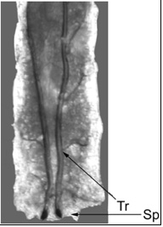
The Drosophila larva is an ideal experimental model for monitoring heart rate because of the ease of measuring heart rate by counting the movement of the trachea. There are attachments from the heart on the trachea. Before starting this experiment, become familiar with the Drosophila anatomy below:

Figure 1. Dorsal view of an intact 3rd instar larva showing trachea (Tr) and spiracles (Sp)

Materials
Item | Quantity
3rd instar larva | 1
Slide | 1
Cover slip | 1
Light Microscope | 1
Set of Microscope Lights | 1
Paper Towels | 2
Beaker of Distilled, Aerated Water | 1
Beaker of Ice | 1
Food laced with 5-HT Solution
Food laced with Dopamine Solution
Drop of Super Glue (Maxi-Cure) | 1

Methods
    - Take a clean slide and place a cover slip at one end of it.
    - Put a small dab of superglue at one corner of the cover slip.
    - Locate your Drosophila larva and remove it from the test tube.
    - Place the larva in a Petri dish and rinse it with a small amount of water to remove any excess food.
    - Soak up reaming food with the corner of a small tissue or paper towel.
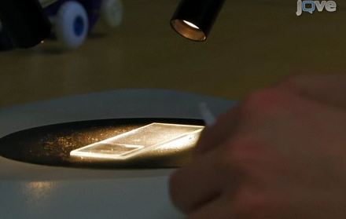
    - Gently pick up larva with tweezers and place it on your slide on the opposite end from your cover slip.
    - Place the slide under the microscope and adjust your lends on the larva. The larva should be on its stomach with its back facing upwards. You can distinguish between the two sides of the larva because their backs feature two “racing stripes” which are the trachea. The stomach has faint horizontal grooves running along it with very fine black hairs.

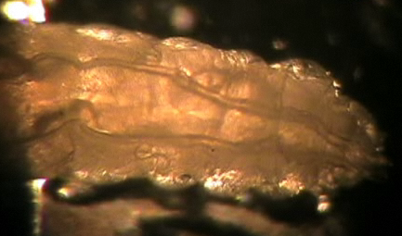
    - If the larva is facing the incorrect way, simply turn the right way by gently flipping it over with your tweezers (See photograph on right).

Intact larvae Protocol
- Restrain the larva to one location using double stick tape on a glass slide and placing the ventral side of the larva to the tape.
- Make sure the black mouth hooks are located near or at the edge of the cover slip and neither they nor the brown spiracles come in contact with the tape.
- Carefully press down on the larva to flatten it out.
- This approach does not work well if the tape gets wet when feeding the larvae. To avoid the tape getting wet use Vaseline (injected out of a small needle around the base of the larvae and around the tape edge). To free the larvae, moisten the tape to loosen the adhesiveness to the animal.
Permanent Restraining Protocol
    - With a new set of tweezers used specifically for glue take a small dab from the drop at the end of your cover slip and place it at the corner of the opposite end. You should use a fractionally amount of glue; just enough to cover the head of the tweezers. Also, make sure you wipe off the ends of your tweezers so that they do not become glued shut.
    - Under the microscope, double check to make sure the larva is still in the correct position. If it has turned over, see step eight.
    - Now, with the tweezers used to handle larva, pick up the larva and place it gently on the fresh patch of glue. Make sure the black mouth hooks are located near or at the edge of the cover slip and neither they nor the brown spiracles come in contact with the glue.
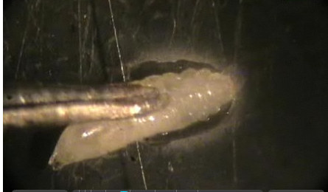
    - Carefully press down on the larva to flatten it out.

Exercise 1.
Monitor the heart rate of the Drosophila to gain a baseline. Count the number of trachea movements in ten seconds and multiply this number by six to get the beats per minute. To obtain an experimental baseline, do this three times and take the average of the three values and record values in Table 1.
Exercise 2.
Note: Your teacher will instruct your group to perform either Part A or Part B of Exercise 2 (NOT both). You will then exchange recorded data with a group that used a different chemical stimulus.
A. While monitoring the Drosophila through the microscope, use a syringe to add dopamine-laced food to the head of the fly. After approximately thirty seconds, count the number of spiracle movements in a ten second period. Multiply this number by six to calculate beats per minute. Repeat this process three times; generate an average beats per minute and record it in Table 1.
B. While monitoring the Drosophila through the microscope, use a syringe to add serotonin-laced food to the head of the fly. After approximately thirty seconds, count the number of spiracle movements in a ten second period. Multiply this number by six to calculate beats per minute. Repeat this process three times; generate an average beats per minute and record it in Table 1.
Exercise 3.
Carefully rinse the food off the slide making sure the Drosophila is secure. While monitoring the Drosophila through the microscope, add chilled water from the beaker containing the ice to the slide. After approximately thirty seconds, count the number of spiracle movements in a ten second period. Multiply this number by six to calculate beats per minute. Repeat this process three times; generate an average beats per minute and record it in Table 1. Water Temperature: _______ °C

Exercise 4.
Carefully rinse the food off the slide making sure the Drosophila is secure. While monitoring the Drosophila through the microscope, add warm water from the beaker to the slide. After approximately thirty seconds, count the number of spiracle movements in a ten second period. Multiply this number by six to calculate beats per minute. Repeat this process three times; generate an average beats per minute and record it in Table 1. Water Temperature: _______ °C
Result:
 | Control (beats/min) | Dopamine (beats/min) | Serotonin (beats/min) | Cold Water (beats/min) | Warm Water (beats/min)
Trial 1
Trail 2
Trail 3
Average

In order to compare the effects upon heart rate of the various conditions observed above, graph the average beats/minute of each stimulus below:
Heart Rate (Beats/Min)
Control Dopamine Serotonin Cold Warm

References
Ashton, K., Wagoner, A.P., Carrillo, R., & Gibson, G. Quantitative trait loci for the monoamine-related traits heart rate and headless behavior in Drosophila melanogaster. Genetics 157, 283-294 (2001).
Azpiazu, N., Frasch, M., Tinman and Bagpipe: Two homeo box genes that determine cell fates in the dorsal mesoderm of Drosophila. Genes & Development 7, 1325-1340 (1993).
Badre, N.H., Martin, M.E., & Cooper, R.L. The physiological and behavioral effects of carbon dioxide on Drosophila melanogaster larvae. Comp Biochem Physiol A Mol Integr Physiol 140, 363-376 (2005).
Baker, J.D., McNabb, S.L., & Truman, J.W. The hormonal coordination of behavior and physiology at adult ecdysis in Drosophila melanogaster. J. Exp. Biol. 202, 3037-3048 (1999).
Bier, E. & Bodmer, R. Drosophila, an emerging model for cardiac disease. Gene 342, 1-11 (2004).
Bodmer, R. The gene tinman is required for specification of the heart and visceral muscles in Drosophila. Development 118, 719-729 (1993).
Bodmer, R., Jan, L.Y., & Jan, Y.N. A new homeobox-containing gene, msh-2, is transiently expressed early during mesoderm formation of Drosophila. Development 110, 661-669 (1990).
Cooper, A.S. & Cooper, R.L. Monitoring activity of Drosophila larvae: Impedance & video microscopy measures. Drosophila Information Service 87, 85-87 (2004).
Dasari, S. & Cooper, R.L. Direct influence of serotonin on the larval heart of Drosophila melanogaster. J. Comp. Physiol. B 176, 349–357 (2006).
Dasari, S., Viele, K., Turner, A.C. & Cooper R.L. Influence of p-CPA and MDMA on physiology, development and behavior in Drosophila melanogaster. European J. Neurosci. 26, 424–438 (2007).
Dowse, H., Ringo, J., Power, J., Johnson, E., Kinney, K., & White, L. A congenital heart defect in Drosophila caused by an action-potential mutation. J. Neurogenetics 10, 153-168 (1995).
Dulcis, D. & Levine, R.B. Glutamatergic innervation of the heart initiates retrograde contractions in adult Drosophila melanogaster. J. Neurosci. 25, 271-280 (2005).
Feng, Y., Ueda, A., & Wu, C.F. A modified minimal hemolymph-like solution, HL3.1, for physiological recordings at the neuromuscular junctions of normal and mutant Drosophila larvae. J. Neurogenetics 18, 377-402 (2004).
Ganetzky, B. Genetic analysis of ion channel dysfunction in Drosophila. Kidney International 3, 766-771 (2000).
Gu G.G. & Singh S. Pharmacological analysis of heartbeat in Drosophila. J. Neurobiol. 28, 269-280 (1995).
He, B. & Adler, P.N. Cellular mechanisms in the development of the Drosophila arista. Mechanisms of Development 104, 69-78 (2001).
Johnson E., Ringo J., & Dowse H. Modulation of Drosophila heartbeat by neurotransmitters. J. Comp. Physiol. B 167, 89-97 (1997).
Johnson, E., Ringo, J., Bray, N., & Dowse, H. Genetic and pharmacological identification of ion channels central to the Drosophila cardiac pacemaker. J. Neurogenetics 12, 1-24 (1998).
Johnson E., Ringo J., & Dowse H. Native and heterologous neuropeptides are cardioactive in Drosophila melanogaster. J. Insect Physiol. 1, 1229-1236 (2000).
Johnson, E., Sherry, T., Ringo, J. & Dowse, H. Modulation of the cardiac pacemaker of Drosophila: cellular mechanisms. J. Comp. Physiol. B, Biochem., Systemic, Environmental Physiol. 172, 227-236 (2002).
Lewis, E. B. A new standard food medium. Drosophila Inform. Serv. 34, 117 (1960).
Miller, T.A. Control of circulation in insects. General Pharmacol. 29, 23-38 (1997).
Molina, M.R. & Cripps, R.M. Ostia, the inflow tracts of the Drosophila heart, develop from a genetically distinct subset of cardial cells. Mechanisms of Development 109, 51-59 (2001).
Muller K.J., Nicholls J.G., & Stent G.S. Neurobiology of the Leech. Cold Spring Harbor, New York: Cold Spring Harbor Laboratory p. 254 (1981).
Nichols R., Kaminski S., Walling E., & Zornik E. Regulating the activity of a cardioacceleratory peptide. Peptides 20, 1153-1158 (1999).
Ocorr, K., Akasaka, T., & Bodmer, R. Age-related cardiac disease model of Drosophila. Mechanisms of Ageing and Development 128, 112-116 (2007a).
Ocorr, K.A., Crawley, T., Gibson, G., & Bodmer, R. Genetic variation for cardiac dysfunction in Drosophila. PLoS ONE 2, e601 (2007b).
Papaefthmiou, C. & Theophilidis, G. An in vitro method for recording the electrical activity of the isolated heart of the adult Drosophila melanogaster. In Vitro Cellular & Developmental Biol. Animal 37, 445-449 (2001).
Peron, S., Zordan, M.A., Magnabosco, A., Reggiani, C. & Megighian, A. From action potential to contraction: Neural control and excitation–contraction coupling in larval muscles of Drosophila. Comp. Biochem.Physiol. A: Molecular & Integrative Physiol. 154, 173-183 (2009).
Ponzielli, R., Astier, M., Chartier, A., Gallet, A., Therond, P., & Semeriva, M. Heart tube patterning in Drosophila requires integration of axial and segmental information provided by the Bithorax Complex genes and hedgehog signaling. Develop. 129, 4509-4521 (2002).
Sláma, K.,& Farkas, R. Heartbeat patterns during the postembryonic development of Drosophila melanogaster. J. Insect Physiol. 51, 489-503 (2005).
Stühmer, W., Roberts, W.S. & Almers, W. The loose patch clamp. In: B. Sakmann and E. Neher (Eds.), Single channel recordings. Plenum Press, New York 123-132 (1983).
Wessells, R.J., & Bodmer, R. Screening assays for heart function mutants in Drosophila. Biotechniques 37, 58-60, 62, 64 passim (2004).
Zornik E, Paisley K, & Nichols R. Neural transmitters and a peptide modulate Drosophila heart rate. Peptides 20, 45-51 (1999).

